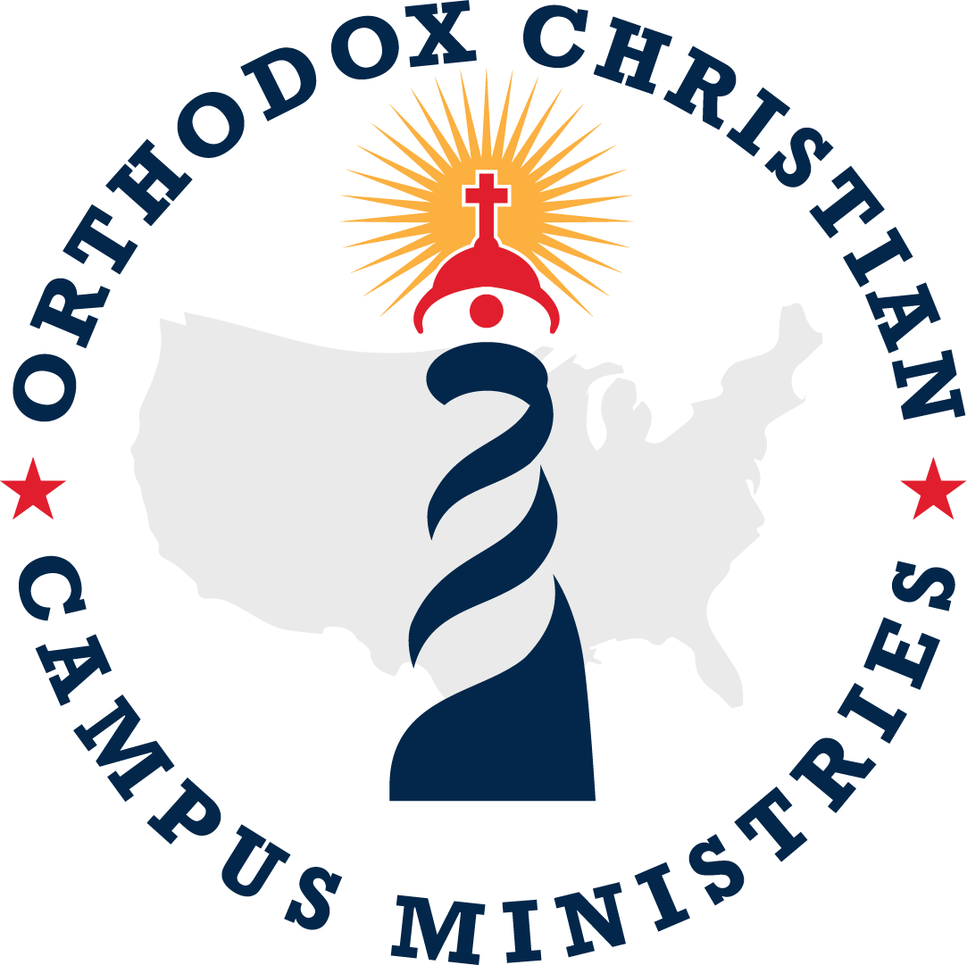
Constitution of the Members of the
Orthodox Christian Campus Ministries
__________________________________________________________

PREAMBLE
We, the Coptic Orthodox Students, of the Diocese of the Southern United States, in order to provide effective Christian fellowship and community cohesion, do hereby adopt this constitution as the guide to our organization; to experience the church through prayer, service, and study of Oriental Orthodox Literature; to evangelize the unique message of Oriental Orthodox Churches; and to deepen involvement of youth into the Oriental Orthodox Community through personal and professional development.

ARTICLE I-NAME AND AFFILIATION:
SECTION I: The incorporated organization shall be entitled: “Orthodox Christian Campus Ministries”. The Orthodox Christian Campus Ministries hereinafter may be referred to as “OCCM” or “The Organization”.

SECTION II: The Coptic Orthodox Patriarchate - Diocese of the Southern United States will serve as the Parent Organization of OCCM.

SECTION III: OCCM will serve as the Parent Organization to all Coptic Orthodox affiliated organizations at any university in the Southern Coptic Diocese of the United States. The collection of these organizations will hereinafter be referred to as “Collegiate Coptic related organizations.”

Article II-AIMS AND OBJECTIVES:
SECTION I: To experience the Coptic Orthodox Christian Church through prayer, service to others, and study of the Faith.

SECTION II: To unite Coptic Orthodox Christian students from different college campuses in Coptic Orthodox worship and fellowship.

SECTION III: To deepen the spiritual and devotional life of university and college students across several campuses through study of Coptic Orthodox Christian doctrine and lifestyle.

SECTION IV: To evangelize on each member’s respective campus the unique message of the Coptic Orthodox Church.

SECTION V: To further the welfare of students in body, mind, and spirit in harmony with the Christian purpose.

SECTION VI: To sponsor diocese-wide activities such as Christian service and lectures by specialists and fathers on topics relevant to Church doctrine and study.

SECTION VII: To increase involvement of youth in the Coptic community through personal, professional, and spiritual development.

ARTICLE III- Membership Qualification:
Section I: Membership in OCCM shall be open to all students affiliated with a Collegiate Coptic related organization. Local chapters will determine eligibility of the member in relation to associated by-laws as established in Article VIII. Associate membership may be granted to students who do not fall into the above category under special circumstances to be determined by the OCCM president. In order for any member to be considered an active member, they must attend the majority (50%+1) of all greater OCCM events.

Section II: Length of term for membership is lifetime. In order to hold Committee positions for the following year, a member must be an active undergraduate student member. Only former OCCM members (OCCM Alumni) are eligible for advisory positions.

Section III: If a OCCM officer cannot attend a meeting or event, they must provide a notice to the meeting leader or the Committee sponsoring the event 24 hours in advance for the absence to be excused. All members are expected to demonstrate commitment to the organization and should show constant effort and enthusiasm for the organization.

Section IV: As representatives of Christ, if any member does not display an appropriate manner of behavior and shows ill-will toward other people or represents the organization in a manner that violates Christian expectation, then that individual’s membership may be subject to revocation.

ARTICLE IV-Governance:
SECTION I: OCCM shall be supervised and coordinated by an elected OCCM President. This President is responsible for leading the organization, overseeing organization meetings and events, and maintaining communication with advisors. Elections and procedures are elaborated in the OCCM by-laws, established in Article VIII.

SECTION II: OCCM shall be governed by the overall OCCM officers and the standing Bishop of the Coptic Orthodox Patriarchate-Diocese of the Southern United States, or his designee, and in coordination with regional directors from each state in the Southern Diocese: Alabama, Arizona, Arkansas, Florida, Georgia, Louisiana, Mississippi, New Mexico, Oklahoma, Tennessee, and Texas. The regional officers will be responsible for facilitating communication across their chapters. The regional officers are selected by the procedure outlined in OCCM Rules of Procedure.

SECTION III: The primary advisor of this organization shall be the standing Bishop of the Coptic Orthodox Patriarchate - Diocese of the Southern United States, or his designee. The primary advisor has the authority to overrule all decisions made by the committees and members of OCCM.

SECTION IV: There will also be five committees as provided by the OCCM by-laws.

SECTION V: The secondary advisors of this organization shall be the Alumni Committee as per Chapter 5.6 of the OCCM Rules of Procedure.

ARTICLE V-Meetings:
SECTION I: OCCM shall hold a general business meeting with the OCCM executive board at the beginning of each month, as outlined in the OCCM Rules of Procedure.

SECTION II: OCCM shall hold a regional meeting with the respective OCCM regional officers and area presidents, as outlined in the OCCM Rules of Procedure.

SECTION III: OCCM should hold a local university chapter meeting each month, as outlined in the OCCM Rules of Procedure.

ARTICLE VI-Limitations and restrictions:
SECTION I: The Organization shall continue in perpetuity.
SECTION II: The Organization shall have no power to take any action that would be inconsistent with the requirements for tax exemption under Internal Revenue Code Section 501(c)(3) and related regulations, rulings, and procedures. The Organization shall have no power to take any action that would be inconsistent with the requirements for receiving tax deductible charitable contributions under Internal Revenue Code Section 170(c)(2) and related regulations, rulings, and procedures. Regardless of any other provision in these Articles of Incorporation or state law.

SECTION III: The Organization shall have no power to engage in activities or use its assets in manners that are not in furtherance of one or more exempt purposes, as set forth above and defined by the Internal Revenue Code and related regulations, rulings, and procedures, except to an insubstantial degree.

SECTION IV: The Organization shall have no power to serve a private interest other than one that is clearly incidental to an overriding public interest.

SECTION V: The Organization shall have no power to devote more than an insubstantial part of its activities to attempting to influence legislation by propaganda or otherwise, except as provided by the Internal Revenue Code and related regulations, rulings and procedures.

SECTION VI: The Organization shall have no power to participate in or intervene in any political campaign on behalf of or in opposition to any candidate for public office. The prohibited activities include the publishing or distributing of statements and any other direct or indirect campaign activities.

SECTION VII: The Organization shall have no power to have objections that characterize it as an “action organization” as defined by the Internal Revenue Code and related regulations, rulings, and procedures.

SECTION VIII: The Organization shall have no power to distribute its assets on dissolution other than for one or more exempt purposes; on dissolution, the Organization’s assets shall be distributed to the state government for a public purpose, or to an organization exempt from taxes under Internal Revenue Code Section 501(c)(3) to be used to accomplish the general purposes for which the Organization was organized.

SECTION IX: The Organization shall have no power to permit any part of the net earnings of the Organization to inure to the benefit of any private shareholder or member of the Organization or any private individual.

SECTION X: The Organization shall have no power to carry on an unrelated trade or business except as a secondary purpose related to the Organization’s primary, exempt, purposes.

SECTION XI: The Organization shall make distributions at such times and in such manners as to avoid the tax under Internal Revenue Code Section 4942. The Organization shall not engage in any act of selfdealing as defined in Section 4941(d). The Organization shall not retain excess business holdings as defined in Section 4943(c). The Organization shall not make any investments that would subject it to the tax described in Section 4944. The Organization shall not make any taxable expenditures as defined in Section 4945(e).

SECTION XII: The Organization shall take no action(s) contrary to the rules, statutes, regulations and usages of the Coptic Orthodox Church of Alexandria adopted by the Synodical Committee for the Coptic Orthodox Churches in Immigration, or contrary to the policies of the Bishop of the Coptic Orthodox Patriarchate - Diocese of the Southern United States.

ARTICLE VII-Hazing:
SECTION I: This organization prohibits its members, both individually and collectively from committing any acts of hazing as defined herein:
"Hazing" as defined by §1006.63, Florida Statutes, means any action or situation that recklessly or intentionally endangers the mental or physical health or safety of a student for purposes including, but not limited to, initiation or admission into or affiliation with any organization operating under the sanction of a postsecondary institution, regardless of a person’s willingness to participate. "Hazing" includes, but is not limited to, pressuring or coercing the student into violating state or federal law; any brutality of a physical nature, such as whipping, beating, branding, exposure to the elements, forced consumption of any food, liquor, drug, or other substance; or other forced physical activity that could adversely affect the physical health or safety of the student; and also includes any activity that would subject the student to extreme mental stress, such as sleep deprivation, forced exclusion from social contact, forced conduct that could result in extreme embarrassment, or other forced activity that could adversely affect the mental health or dignity of the student. Hazing does not include customary athletic events or other similar contests or competitions or any activity or conduct that furthers a legal and legitimate objective.”

ARTICLE VIII-By-Laws
Section I: OCCM will abide by the accompanying by-laws titled, “OCCM Rules and Procedures.” The OCCM Constitution and OCCM Rules and Procedures are both subject to the standing Bishop of the Coptic Orthodox Patriarchate - Diocese of the Southern United States.

ARTICLE IX-Constitutional amendments:
SECTION I: Any OCCM member may propose an amendment to the OCCM constitution at the General Business Meeting, or the Bishop of the Diocese of the Southern United States or his designee may propose and amend the constitution at any time.

SECTION II: Changes to this Constitution shall be placed at the end of this document and must be approved by a supermajority (2/3) vote of all OCCM committee members and associated officers or the Bishop of the Diocese of the Southern United States or his designee at any time.

SECTION III: An approved constitutional amendment shall not take effect until the following OCCM year, which begins on June 1st, unless deemed urgent by a more than half vote of a committee consisting of the OCCM President, OCCM VP, and each of the three Regional Directors or the Bishop of the Diocese of the Southern United States or his designee at any time.

SECTION IV: Any approved constitutional amendment is subject to approval by the standing Bishop of the Coptic Orthodox Patriarchate - Diocese of the Southern United States or his designee.

SECTION V: Unless otherwise specified by the Bishop or his designee, if there should ever be conflict between the OCCM Constitution and the OCCM Rules of Procedure, the Constitution shall prevail.

